Unit 3 - (Quadratics 1) - Outline

Day | Lesson Title | Specific Expectations
1 | Graphs of Quadratic Relations | A1.1, A1.2
2 | The Parabola | A1.1, A1.2
3 | Exploring Vertex Form | A1.3
4 | Graphing Parabolas | A1.4
5 | Factored Form of a Quadratic Relation | A1.8
6 | Quadratics Consolidation | A1.9
7 | Review Day
8 | Test Day
TOTAL DAYS: |  | 8

A1.1- construct tables of values and graph quadratic relations arising from real-world applications (e.g., dropping a ball from a given height; varying the edge length of a cube and observing the effect on the surface area of the cube);
A1.2 - determine and interpret meaningful values of the variables, given a graph of a quadratic relation arising from a real-world application (Sample problem: Under certain conditions, there is a quadratic relation between the profit of a manufacturing company and the number of items it produces. Explain how you could interpret a graph of the relation to determine the numbers of items produced for which the company makes a profit and to determine the maximum profit the company can make.);
A1.3 - determine, through investigation using technology, and describe the roles of a, h, and k in quadratic relations of the form y = a(x – h)² + k in terms of transformations on the graph of y = x2 (i.e., translations; reflections in the x-axis; vertical stretches and compressions) [Sample problem: Investigate the graph y = 3(x – h)² + 5 for various values of h, using technology, and describe the effects of changing h in terms of a transformation.];
A1.4 - sketch graphs of quadratic relations represented by the equation y = a(x – h)² + k (e.g., using the vertex and at least one point on each side of the vertex; applying one or more transformations to the graph of y = x²);
A1.8 – determine, through investigation, and describe the connection between the factors of a quadratic expression and the x-intercepts of the graph of the corresponding quadratic relation (Sample problem: Investigate the relationship between the factored form of 3x² + 15x + 12 and the x-intercepts of y = 3x² + 15x + 12.);
A1.9 – solve problems, using an appropriate strategy (i.e., factoring, graphing), given equations of quadratic relations, including those that arise from real-world applications (e.g., break-even point) (Sample problem: On planet X, the height, h metres, of an object fired upward from the ground at 48 m/s is described by the equation h = 48t – 16t², where t seconds is the time since the object was fired upward. Determine the maximum height of the object, the times at which the object is 32 m above the ground, and the time at which the object hits the ground.).

Unit 3 Day 1: Graphs of Quadratic Relations |  |  |  | MBF 3C
 |  | Description  Students will produce quadratic data  Students will produce quadratic plots form data  Students will recognize the general shape of the graph of a quadratic relation |  | Materials BLM 3.1.1 –3.1.6  hexalink cubes  toothpicks  graph paper
Assessment
Opportunities
 | Minds On… | Whole Class and Groups → Discussion  Display on an overhead BLM 3.1.1 which details the cost for a group to enter an amusement park. Ask each row, “If you are the park manager, and you wish to get the most money from each group, what size of a group will bring in the most money?” Each group proposes a hypothesis as to the best number of people to enter to get the most income for the park. Each row then calculates the amount earned for their guess. The guesses and prices are written on the board (or overhead) and the results are discussed. You may wish to guess a number of your own to model the idea.  Whole Class → Brainstorm  Ask: What number of people would cause the maximum income?  Encourage students to use the data from the discussion to justify their answer.
 | Action! | Small Groups → Activity (Achievement Stations)  Divide the class up into groups of 3 or 4 and give each group a different Activity Sheets (3 in total, some require additional materials)  For all activities, each member of a group needs to completely fill out the worksheet and the group must show completed sheets before receiving new worksheet. The worksheets should be self-explanatory to the students.  Activity 1 (BLM 3.1.2): Finding the maximum profit (similar to warm-up)  Activity 2(BLM 3.1.3): Finding maximum area ** need toothpicks and graph paper **  Activity 3 (BLM 3.1.4): Calculating surface area of a cube ** need hexalink cubes**
 | Consolidate Debrief | Whole Class → Discussion  Students report on their findings on the three activities.  Stress concepts of non-linearity, the meanings of the vertex and x-intercepts in Activity #1 and #2  Show students BLM 3.1.5 (which is the completed question for the “Minds On”) and again focuses on vertex, the idea of maximum, what the x – intercepts mean, etc.
Concept Practice  Exploration |  | Home Activity or Further Classroom Consolidation Students receive BLM 3.1.6 and a piece of graph paper for independent work
MBF3C
BLM 3.1.1

Welcome to
Fasool’s Fantastic Funland

Where FUN is all that matters…

Today’s Special Group Rates:
- A group of 20 costs $40 per person.
- For every extra person, you save 50¢ per person. (Example… a group of 21 costs $39.50 each)
- For groups below 20, it costs 50¢ more for each person below 20 (Example… a group of 17 costs $41.50 each)
Row | # in group | Total $
MBF 3C Name:
BLM 3.1.2 Date:

Quadratics Warm-Up: Activity 1
Congratulations! You have made it to the math cheerleading team. Just imagine: a group of dedicated mathletes spreading the cheer of math throughout the school! The best part about being on the math cheerleading team is that you get paid… per cheer! Of course, since the team is a MATH team, it takes a bit of calculating to figure out how much you get paid.

Here’s what the coach told you:

If you do 10 cheers, you get paid $2 per cheer (NOT BAD!)
You will get 10¢ less per cheer for every cheer over 10 cheers, but you will get 10¢ more per cheer for every cheer under 10 cheers.

The question going around the team is “How many cheers do we need to do in order to get the most money possible?”

Fill in the table below to find out (start at 10 cheers and work up and down)

Number of Cheers | Price per Cheer | Total Money Paid  (1st × 2nd columns)
7 | $2.30
8 | $2.10 + 10¢ = $2.20
9 | $2.00 + 10¢ = $2.10
10 | $2.00 | 10 × $2.00 = $20.00
11 | $2.00 – 10¢ = $1.90
12
13
14
15
16
17
18

Conclusion: The maximum money of _______ is paid when you do _____ math cheers.
MBF 3C Name:
BLM 3.1.2 Date:

Quadratics Warm-Up: Activity 1 (continued)

Plot the data from the other side on the grid below:

Cheers for Cash?
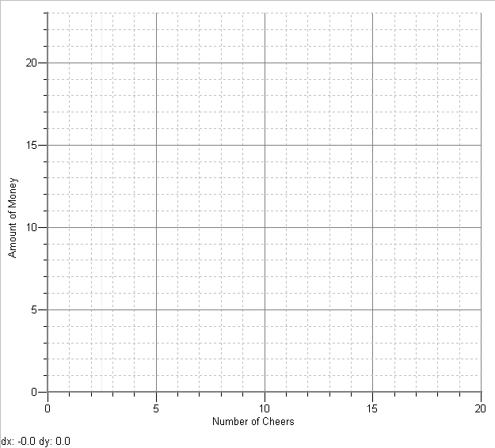

MBF 3C Name:
BLM 3.1.2 Date:
Quadratics Warm-Up: Activity 2

You have been given 20 sections of chain-link fence to reserve an area in a new park which will be used as a wading pool in the future. The only instruction from the construction foreman was to reserve the “biggest rectangular area possible.”

The 20 toothpicks you have will represent the sections of the fence. Use the table below to design 9 different “pool areas”. On the graph paper provided draw all 9 rectangles (one grid space = one section of fence) and label them with the correct rectangle label (A, B, C, etc)
Remember, area of a rectangle is length × width!
(Or count the # of squares in the rectangle on your graph paper!)

Rectangle Label | If the length of the pool is… | Diagram  (not drawn to scale) | Then the width is… | And the area is…  (units are sections²)
A | 1 section | 1  1  9  9 | 9 sections | 1 × 9 = 9
B | 2 sections
C | 3 sections
D | 4 sections
E | 5 sections
F | 6 sections
G | 7 sections
H | 8 sections
I | 9 sections

Conclusion: The maximum area of ________ sections² occurs when the area is ______ sections long and ______ sections wide
MBF 3C Name:
BLM 3.1.2 Date:
Quadratics Warm-Up: Activity 2 (continued)

Plot the data from the other side on the grid below:

What’s The Biggest Pool?
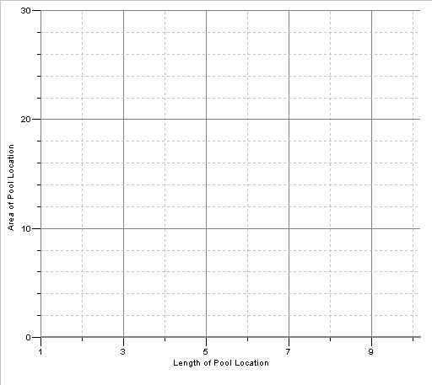
2
4
6
8

MBF 3C Name:
BLM 3.1.2 Date:
Quadratics Warm-Up: Activity 3

In this activity you will determine the relationship between the side-length of a cube and its surface area.

You can use hexalink cubes for the first few examples of this activity, but you will have to mentally calculate the surface area when the cubes become too big for you to build.
Fill in the side-length and surface area in the table below and then plot the data in the grid provided (as much data as can fit on the plot). The first one has been done for you. This is basically a single cube. It has a side length of one (it’s made of only 1 cube!) and it has 6 squares showing on all its faces (that’s why the surface area is 6). A cube with a side length of 2 would be a 2 × 2 × 2 cube. The surface area is the area of all the faces (count the number of squares on all the faces!)

Side Length | Surface Area  (Side Area x # of sides) |  | Side Length | Surface Area  (Side Area x # of sides)
1 | 6 |  | 5
2 |  |  | 6
3 |  |  | 7
4 |  |  | 8

Surface Area vs Side Length of a Cube
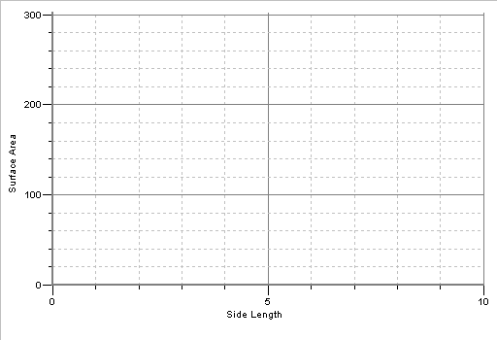

MBF 3C Name:
BLM 3.1.2 Date:
Remember
Fasool’s Fantastic Funland?
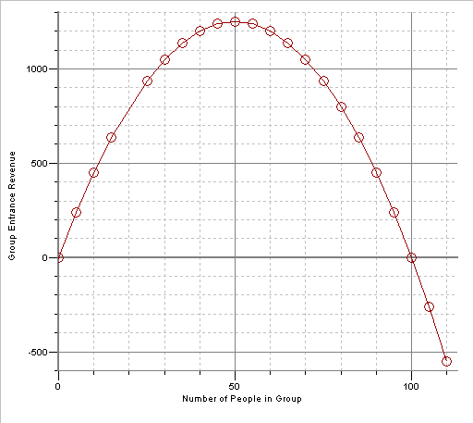
Questions
- In order to get the most money from a group, how many members should the group have?
- What is the maximum revenue?
- What is the revenue from a group of 20?
- What happens at 0 people and 100 people?
- What happens after 100 people? Does this make sense? Explain.
MBF 3C Name:
BLM 3.1.2 Date:
Quadratics Warm-Up: Homework
Question 1:
Complete the table below and then graph the data on graph paper.

A rectangular display is to be surrounded by neon string lights. The area of the display is to be as large as possible and it must be completely surrounded by the string lights which have a total length of 120 cm.

If the length of one side is… | Diagram  (not drawn to scale) | Then the length of the other side is… | And the area is…  (units are cm²)
5 cm | 5  5  55  55
15 cm
25 cm
35 cm
45 cm
55 cm

MBF 3C Name:
BLM 3.1.2 Date:
Quadratics Warm-Up: Homework

Question 2:
The promotions manager of a new band is deciding how much to charge for concert tickets. She has calculated that if the tickets are $30 each, then 200 people will come to the concert. For every $1 increase in the price, 10 less people will come. Create a table to calculate how much should be charged to MAXMIZE the revenue from the ticket sales.

Ticket Price | Number of People | Total Money From Tickets
$29

$30 | 200 | $30 × 200 = $6000

Unit 3 Day 2:The Parabola |  |  |  | MBF 3C
 |  | Description  Students will learn to identify important parts of a parabola  Students will apply parabola vocabulary to parts of a graph which represents a real-life event |  | Materials  BLM 3.2.1 to BLM 3.2.3
Assessment
Opportunities
 | Minds On… | Independent Work → Review/Extend  As students enter the class they receive BLM 3.2.1 to work on independently. Instruct them to ignore the #1 to #5 blanks at the bottom of the page for now.  Whole Class → Discussion  After the class has finished with the worksheet, review BLM3.2.1 with the students. When each important item is touched upon (maximum profit – vertex, break even points – zeros, etc) make note if further investigation may be needed of these concepts.
 | Action! | Independent Work → Read  Distribute BLM 3.2.2 and have students explore on the first page the vocabulary of the parabola  Whole Class → Discussion  Discuss second page of BLM 3.2.2 and use it to detail the important aspects of a parabola. Fill in the blanks with the students and highlight the important aspects of the parabola.
 | Consolidate Debrief | Whole Class → Graphing Challenge  Provide each student with BLM 3.2.3 (double sided).  Students draw parabolas from your instructions onto the mini grids. It can be a row vs row challenge to draw the most accurate parabola or a challenge to each member of the class.  Parabola 1:  Draw the parabola with vertex of (3, 4) and zeros at 1 and 5  Parabola 2:  Draw the parabola with a minimum value of -8, zeros at 2 and -2 and y – intercept of -8.  [Vertex should be at (0, -3)]  Parabola 3:  Draw the parabola with a zero at (1, 0) the vertex at (3, -4) and y – intercept of (0,5)  [This parabola should pass through (5, 0) and (6, 5) due to symmetry]  Parabola 4:  Draw the parabola with axis of symmetry of x = -2, optimal value of -3. This parabola has no zeros.  [Parabola has to open down, must have vertex at (-2, -3) and have proper shape (but its width is not important)]
Application  Concept Practice |  | Home Activity or Further Classroom Consolidation  Students label the following parts of the parabola on BLM3.2.1  Have students fill in the 5 blanks at the bottom of the page with:  - Vertex  - Zeroes  - Axis of symmetry  - Optimal Value  - Y – intercept  Students draw the following parabolas on the mini grids from BLM3.2.3.  Parabola 1:  Draw the parabola with vertex of (-2, 4) and zeros at -1 and -3  Parabola 2:  Draw the parabola with a minimum value of 2,no zeros and a y-intercept of 8.  Parabola 3:  Draw the parabola with a zero at (2, 0) the vertex at (3, -4) and a y-intercept of (0, 12)  Parabola 4:  Draw the parabola with axis of symmetry of x = 2, optimal value of 4. This parabola one zeros at the origin

MBF 3C Name:
BLM 3.1.2 Date:

Jim’s In The Money!
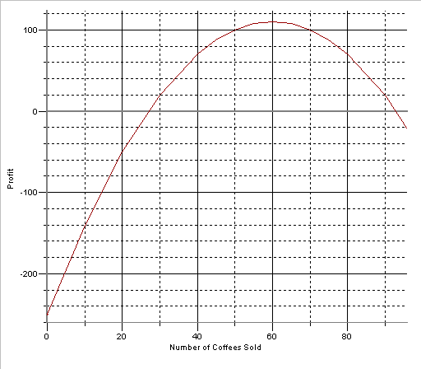

The graph above shows the profit each day for Jim Norton’s roadside coffee stand.
- Approximate how many coffees that Jim needs to sell in order to “break even”? ____________________________

- How many coffees does Jim need to sell to make the maximum possible profit? __________

- If he sells no coffees in a day, how much money does he make (or lose)? _____________

- How many coffees does he need to sell to make $100? ___________________

1. _________ 2. _________ 3. _________ 4. _________ 5. _________
MBF 3C Name:
BLM 3.1.2 Date:
Introducing… The Parabola!

The graph of a quadratic relation is called a parabola. The parabola has some important features:
_zero_______
__y - intercept__
___vertex_____
___zero_____
_axis of symmetry___

__optimal value__

Everything you ever wanted to know about parabolas…

- Parabolas can open up or down

- The zero of a parabola is where the graph crosses the x – axis

- “Zeroes” can also be called “x – intercepts” or “roots”

- The axis of symmetry divides the parabola into two equal halves

- The vertex of a parabola is the point where the axis of symmetry and the parabola meet. It is the point where the parabola is at its maximum or minimum value.

- The optimal value is the value of the y co-ordinate of the vertex

- The y-intercept of a parabola is where the graph crosses the y – axis
MBF 3C Name:
BLM 3.1.2 Date:
Introducing… The Parabola! (Continued)

For the following parabolas, fill in the table which follows.
y
Parabola Graph | y  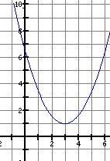  x | y  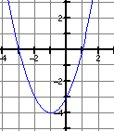  x | 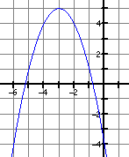  x
Vertex

Optimal Value

Axis of Symmetry

Zeroes

Direction of Opening

Y – intercept

True or False… (use the above for answers)
______ | The axis of symmetry goes through the y – intercept.
______ | The vertex is always located halfway between the zeroes.
______ | The y – coordinate of the vertex is always the same as the optimal value.
______ | The x – coordinate of the vertex is always the same as the axis of symmetry.
______ | A parabola must open up.
______ | The y – intercept is always positive.
MBF 3C Name:
BLM 3.1.2 Date:
Parabola Practice
Unit 3 Day 3: Exploring Vertex Form |  |  |  |  |  |  |  |  |  |  |  |  |  |  |  |  |  |  |  |  |  |  |  |  |  |  | MBF 3C
 |  |  |  |  |  | Description  Students will use technology to explore vertex form of a parabola |  |  |  |  |  |  |  |  |  |  |  |  |  |  |  |  |  |  |  |  | Materials  TI83  BLM3.3.1 –  BLM3.3.3
Assessment
Opportunities
 | Minds On… |  |  |  |  | Whole Class → Discussion  On overhead, show BLM 3.3.1 and discusses various aspects of the graph.  This may be best done using an overhead graphing calculator, with the equation y = 0.5(x – 10)² – 15. This will help solidify different skills needed for the worksheet later in the period (i.e. using TABLE command to get a table of values, entering a equation into the calculator, graphing, etc)
 | Action! |  |  |  |  | Pairs → Explore  Complete the first page of BLM3.3.2 with the students. Students continue to work through BLM 3.3.2 using the TI-83 graphing calculator or by hand.
 | Consolidate Debrief |  |  |  |  | Whole Class → Discussion  Discuss from the exploration the key principals. Focus on the equation  y = a(x – h)${}^{2}$ + k and the meaning of the different variables.  Lead students through a study of parabolas and fill in a few blanks on the table from BLM3.3.3.
Application  Concept Practice |  |  |  |  |  | Home Activity or Further Classroom Consolidation  Students complete the remaining cells of the table on BLM3.3.3 and sketch a graph of any of the five quadratics from the table..

MBF3C Name:
BLM 3.3.1 Date:
A Paper Airplane Ride
Tatiana has walked to a water tower beside a nearby gorge in order to launch her newly designed paper airplane. The graph below shows the flight of the paper airplane. A negative height means the airplane is below the level of the ground. (Height in feet and time in seconds)
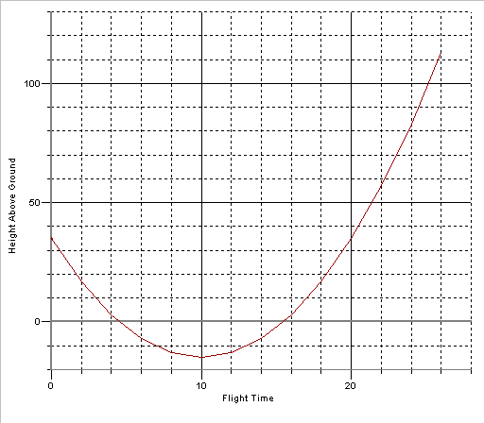
- Estimate the height of the water tower ________________

- How long does it take for the paper airplane to reach its minimum height? _________

- How high is the minimum height? _____________

- When has the paper airplane reached ground level? _______________________

- Write the vertex of this parabola: ___________________

- Will the airplane continue in a parabolic path? Explain why or why not.
MBF3C Name:
BLM 3.3.2 Date:
Vertex Form of a Parabola

In this investigation you will graph different parabolas and compare them to what is known as the “Basic Parabola”.

TECHNOLOGY OPTION
Y =
To help you graph and plot the parabolas, enter the equation in the
graph
screen on your TI – 83 graphing calculator, press to see the graph and
graph
2nd
press to see a table of values for the parabola

THE BASIC PARABOLA
Equation | y = x²
Table of Values
x | y
-3
-2
-1
0
1
2
3
Fill in the following information about the parabola:
What is the vertex? _________ | What is the Direction of Opening? ____________ | What’s the “step pattern” of the parabola? (how do you move from point to point, starting from the vertex? – and it doesn’t matter if you go to the right or left) | Over 1
What is the vertex? _________ | What is the Direction of Opening? ____________ |  | Over 1
What is the vertex? _________ | What is the Direction of Opening? ____________ |  | Over 1

Since all parabolas have their “over” steps the same, we usually refer to these three numbers as the Step Pattern of the parabola
So, the Step Pattern of this parabola is

______, ______, _____

You will now graph parabolas with different equations than the Basic Parabola (y = x²) and you will compare the new parabola to the graph of the Basic Parabola.

MBF3C Name:
Equationy = x² + 2Table of Valuesxy-3-2-10123Fill in the following information about the parabola:What is the vertex? _________Direction of Opening? ____________What’s the Step Pattern?Over 1Over 1Over 1

PARABOLA INVESTIGATION #1
Equationy = x² - 3Table of Valuesxy-3-2-10123Fill in the following information about the parabola:What is the vertex? _________Direction of Opening? ____________What’s the Step Pattern?Over 1Over 1Over 1

PARABOLA INVESTIGATION #2
What is the effect when a number is added or subtracted to the equation of the Basic Parabola?
BLM 3.3.2 Date:

MBF3C Name:
Equationy = (x – 3)² Table of Valuesxy0123456Fill in the following information about the parabola:What is the vertex? _________Direction of Opening? ____________What’s the Step Pattern?Over 1Over 1Over 1

PARABOLA INVESTIGATION #3
Equationy = (x + 4)²Table of Valuesxy-7-6-5-4-3-2-1Fill in the following information about the parabola:What is the vertex? _________Direction of Opening? ____________What’s the Step Pattern?Over 1Over 1Over 1

PARABOLA INVESTIGATION #4
What is the effect when a number is added or subtracted to the x (in brackets) of the equation of the Basic Parabola?
BLM3.3.2 Date:

MBF3C Name:
BLM3.3.2 Date:
Equationy = 2x² Table of Valuesxy-3-2-10123Fill in the following information about the parabola:What is the vertex? _________Direction of Opening? ____________What’s the Step Pattern?Over 1Over 1Over 1

PARABOLA INVESTIGATION #5
Equationy = -3x²Table of Valuesxy-3-2-10123Fill in the following information about the parabola:What is the vertex? _________Direction of Opening? ____________What’s the Step Pattern?Over 1Over 1Over 1

PARABOLA INVESTIGATION #6
What is the effect when a positive or negative number is multiplied to the equation of the Basic Parabola?

MBF3C Name:
BLM3.3.3 Properties of a Parabola Date:

1. Complete the following table.

Equation | Vertex | Step Pattern From Vertex | Direction of Opening
y = (x – 2)² + 1

y = -(x + 4)² + 6

y = 4(x – 4)² – 1

y = 3(x + 7)² – 4

y = -2(x – 10)² + 100

y = (x – 4)² + 15

y = -2(x + 2)² + 64

y = 5(x – 10)² – 11

 | (-3, -3) | 2, 6, 10 | Up
 | (20, -10) | -1, -3, -5 | Down

2. Sketch the graph of any five of the above quadratics from the table above.

MBF3C
BLM3.3.3 Properties of a Parabola (Teacher)

Equation | Vertex | Step Pattern From Vertex | Direction of Opening
y = (x – 2)² + 1 | (2, 1) | 1, 3, 5 | Up
y = -(x + 4)² + 6 | (-4, 6) | -1, -3, -5 | Down
y = 4(x – 4)² – 1 | (4, -1) | 4, 12, 20 | Up
y = 3(x + 7)² – 4 | (-7, -4) | 3, 9, 15 | Up
y = -2(x – 10)² + 100 | (10, 100) | -2, -6, -10 | Down
y = (x – 4)² + 15 | (4, 15) | 1, 3, 5 | Up
y = -2(x + 2)² + 64 | (-2, 64) | -2, -6, -10 | Down
y = 5(x – 10)² - 11 | (10, -11) | 5, 15, 25 | Up
y = 2(x + 3)² – 3 | (-3, -3) | 2, 6, 10 | Up
y = -(x – 20)² - 10 | (20, -10) | -1, -3, -5 | Down

Unit 3 Day 4: Graphing Parabolas Using Vertex Form |  |  |  | MBF 3C
 |  | Description  Students will use the vertex form of a quadratic relation to graph |  | Materials  BLM 2.4.1 to BLM 2.4.3
Assessment
Opportunities
 | Minds On… | Whole Class → Discussion  Using the parabola y = 2(x – 3)² + 4 written on the board…  Ask  - What kind of relationship is it? [Quadratic]  - How do we know it’s quadratic?  [(1) equation has an x${}^{2}$ in it, (2) second differences are the same (demonstrate with a table of values) and (3) the graph is a parabola]  - What’s the vertex, direction of opening and step pattern?  Allude to the fact that before we graphed a parabola using just a general shape, but now that we have the step pattern we can graph the parabola EXACTLY!
 | Action! | Partners → Practice  In partners, students work on BLM 3.4.1 and practice identifying information from vertex form, as well as graphing the parabola. They work separately on each parabola, then share solutions  Whole Class → Discussion  Take up BLM 3.4.1 on overhead
 | Consolidate Debrief | Individual Work →Application  Using the concept of vertex form, students work on BLM 3.4.2 which uses vertex form in an application setting.
Concept Practice |  | Home Activity or Further Classroom Consolidation  Students complete BLM3.4.3.

MBF3C Name:
BLM 3.4.1 Date:
Graphing Using Vertex Form
Parabola 1 |  |  |  |  |  |  |  |  |  |  |  |  | Parabola 2
Quadratic Relation is…  y = 2(x + 1)² – 8 |  |  |  |  |  |  |  |  |  |  |  |  | Quadratic Relation is…  y = -(x - 3)² +4
From the equation it can be seen…  The vertex is ____________  The parabola opens ____________  The step pattern is ____, ____, ____ |  |  |  |  |  |  |  |  |  |  |  |  | From the equation it can be seen…  The vertex is ____________  The parabola opens ____________  The step pattern is ____, ____, ____
Graph the parabola |  |  |  |  |  |  |  |  |  |  |  |  | Graph the parabola
From the graph it can be seen…  The zeros are ________ and ________  The y – intercept is ______  The optimal value is _______  The axis of symmetry is _______ |  |  |  |  |  |  |  |  |  |  |  |  | From the graph it can be seen…  The zeros are ________ and ________  The y – intercept is ______  The optimal value is _______  The axis of symmetry is _______

MBF3C Name:
BLM3.4.2 Date:
Money, Money, Money

A study of the finances of Dominion Motors has shown that the profit of the company can be described by the equation
P = -2(n – 200)² + 450 000
Where P represents profit and n represents number of cars sold

- What is the maximum possible profit possible? ____________

- How many cars need to be sold to achieve this profit? _______

- What other information could the graph of this function provide?

Sub’s Way
The Canadian Armed Forces are testing their new aerial-entry rescue yacht. This craft is dropped into the water from an air transport; it then follows a parabolic underwater path while resurfacing. The specifications indicate that the parabolic path is 6m in width, and reaches a depth of 18m.
- On the graph, the yacht enters the water at (0, 0). Sketch its path.

- Write the parabola’s equation

- If properly “aimed” could the yacht be sent under a rectangular boat that was 4m wide, but floated 3m deep?

MBF3C Name:
BLM3.4.2 Date:
The Golden Arch

A decorative arch is to be built over a fountain at the Mathematician’s Hall of Fame. The arch will be in the shape of a parabola and be 4m tall at the centre. Inscribed on a plaque located near the fountain will be the equation of the arch:
y = –0.25(x – 4)² + 4

- graph the shape of the arch, using the grid below where one square represents 0.25m. (the entire arch will not be graphed!)

- How far apart are the “feet” of the arch?

- A stunt pilot wants to hang-glide through the arch during the opening ceremonies. She can modify her hang-glider to have a wingspan of 2m and will fly at a height of 1.5 m above the ground. Will she fit through the arch? Explain your reasoning.

- At what points is the arch 2m high? Find a graphical and algebraic way of answering this question.

MBF3C Name:
BLM 3.4.3 Date:
Graphing Parabolas Homework

1. For the following quadratic relations, fill in the table:
Equation | y = 3(x – 4)² – 8 | y = –2(x + 1)² | y = –(x + 2)² + 10
Vertex
Direction of Opening
Step Pattern
Max or Min?
Optimal Value
Axis of Symmetry

2. Graph the parabolas defined by the above equations.

Unit 3 Day 5: Factored Form of a Quadratic |  |  |  | MBF 3C
 |  | Description  Students will connect the zeros of a parabola to the factors in the equation of a quadratic relation. |  | Materials  BLM 3.5.1 to 3.5.3
Assessment
Opportunities
 | Minds On… | Whole Class → Discussion  Put an equation of a parabola on the board (for example y = -2(x + 3)² – 10) and proceeds to ask questions about it: like:  - What information can we get from this equation?  [vertex, direction of opening, step pattern]  - If we know the vertex, direction of opening, step pattern, what can we determine?  [a graph of the parabola, axis of symmetry, optimal value]  - What are the x-intercepts (zeroes) of the parabola?  [can’t find them, not enough info]  - How could you find the zeroes?  [Use the information and graph the parabola to locate zeroes]  At this point allude to how nice it would be if there was an equation that would show you the zeroes as quickly as the Vertex Form shows you the vertex.
 | Action! | Pairs → Investigate  Complete the first page of BLM3.5.1 with the students.  Students continue to investigate the parabola properties from BLM 3.5.1 using TI-83 graphing calculator if so desired.  Whole Class → Discussion  On overhead or board, review the solutions to BLM 2.5.1
 | Consolidate Debrief | Individuals → Consolidate  Students work on BLM 3.5.2  Whole Class → Discussion  On overhead or board, review the solutions to BLM 3.5.2
Application  Concept Practice |  | Home Activity or Further Classroom Consolidation  Students receive BLM 3.5.3 for practice work
MBF3C Name:
BLM 3.5.1 Date:
Exploring the Factored Form of a Parabola

In this investigation you will graph different parabolas and determine the link between the equation in “factored form” and the zeroes of the parabola.

You will need to be able to determine the following about a parabola:
The zeroes
The direction of opening
The axis of symmetry
The step pattern

TECHNOLOGY OPTION
Y =
To help you graph and plot the parabolas, enter the equation in the
graph
screen on your TI – 83 graphing calculator, press to see the graph and
graph
2nd
press to see a table of values for the parabola

Equationy = (x – 1)(x + 1)Table of Valuesxy-3-2-10123Fill in the following information about the parabola:What is the Direction of Opening? ____________What are the zeroes?

_____ and ______
What is the axis of symmetry?
_________
What is the step pattern?

____, ____, ____

Parabola Investigation #1

MBF3C Name:
Equationy = (x – 3)(x + 1)Table of Valuesxy-2-101234Fill in the following information about the parabola:Direction of Opening? ____________What are the zeroes?

_____ and ______What is the axis of symmetry?
_________Step pattern?

____, ____, ____

Parabola Investigation #2
BLM3.5.1 Date:

Equationy = –2(x + 1)(x + 5)Table of Valuesxy-6-5-4-3-2-10Fill in the following information about the parabola:Direction of Opening? ____________What are the zeroes?

_____ and ______What is the axis of symmetry?
_________Step pattern?

____, ____, ____

Parabola Investigation #3
What is the relationship between factored form and the zeroes of the parabola?
MBF3C Name:
BLM3.5.2 Date:
Factored Form of a Parabola

Factored Form of a Quadratic Relation:
y = a(x – s)(x – t)

This controls the direction and opening as well as the step pattern (same as in vertex form!)
The opposites of these numbers are the zeroes of the parabola. In this case, the parabola would have zeroes of s and t. (or officially, (s, 0) and (t, 0)

Practice: Fill in the table for each parabola equation.
Equation | y = 3(x – 3)(x + 5) | y = –(x + 2)(x + 6) | y = x(x + 8)
Zeros
Direction of Opening
Axis of Symmetry
Step Pattern

Practice: Find the vertex of the middle parabola, and then sketch it.

MBF3C Name:
BLM 3.5.3 Date:
More about the parabola!

- Fill in the table for each parabola equation. BE CAREFUL! Some information is not given by certain equations!

Equation | y = 2(x – 5)(x + 9) | y = –(x + 2)² + 6 | y = 4(x+2)(x + 8)
Zeros
Direction of Opening
Axis of Symmetry
Step Pattern
Vertex

- A cannonball is shot into the air. Its height can be described by the equation h = -3(t – 1)(t – 9) where h is height in feet and t is time in seconds.

- What are the zeroes of this relation? _________ and _________

- What do the zeroes mean in this situation?

- What is the axis of symmetry and what does it represent?

- Use the axis of symmetry to find the vertex and explain what the vertex means for the cannonball.

- The equation P = -0.5(n – 500)(n – 10) describes a company’s profit P, based on how many units are sold, n. What are the break even points of the company, and how many units must be sold to make a maximum profit?

Unit 3 Day 6: Quadratics Consolidation |  |  |  | MBF 3C
 |  | Description  Students will consolidate and solidify their understanding of quadratics, vertex form, and factored form. |  | Materials  BLM 3.6.1 cut out as cards  Spaghetti (strand)  Marshmallows (connector)
Assessment
Opportunities
 | Minds On… | Pairs → Brainstorm  Pair up students as they enter the classroom.. On the board is the question: What do you know about quadratics? Pairs are to brainstorm thoughts and ideas and jot them down.  Whole Class → Discussion/Brainstorm  As a class the board (large chart paper to display) is then filled with the unit knowledge about quadratics.  Key concepts:  Parts of a parabola  Identifying Quadratics  What parabola means for profit, projectile, etc type questions  Vertex form  Factored Form  Graphing parabolas |  | Solutions to keep track of which team has done what question
 | Action! | Groups → Challenge  The challenge is to build the biggest tower using certain materials (sticks and connectors if available, or marshmallows and spaghetti strands). Each group starts with 10 strands and 5 marshmallows. To earn more building materials they answer quadratic questions from the quadratics card pack. (each card details how many materials are won if the question is answered correctly i.e. S:3, M:5 means 3 spaghetti and 5 marshmallow pieces)  Teacher uses his/her card to keep track of which groups have answered which questions. The teacher should be aware of questions that cause concern. |  | Solutions to keep track of which team has done what question
 | Consolidate Debrief | Whole Class → Discussion  Lead the class through the solutions of 2 or 3 of the difficult or poorly done questions. |  | Solutions to keep track of which team has done what question
Differentiated |  | Home Activity or Further Classroom Consolidation  Assign copies of some of the card from BLM3.6.1 pack as an assignment.

MBF3C
BLM3.6.1

Question 1 | Building Reward |  | Question 2 | Building Reward
Question 1 | S: 2 | M: 3 | Question 2 | S: 2 | M: 3
What are the zeroes of  y = (x – 4)(x + 8) ? |  |  | What are the zeroes of  y = -2(x – 5)(x + 17) ?
Question 3 | Building Reward |  | Question 4 | Building Reward
Question 3 | S: 3 | M: 5 | Question 4 | S: 2 | M: 3
What is the axis of symmetry of  y = (x – 5)(x + 13) ? |  |  | What is the axis of symmetry of  y = 3(x – 4)² + 8 ?
Question 5 | Building Reward |  | Question 6 | Building Reward
Question 5 | S: 10 | M: 10 | Question 6 | S: 7 | M: 7
What are the zeroes of  y = 2(x + 3)² – 8 ? |  |  | What is the vertex of  y = (x – 4)(x + 8) ?

MBF3C
BLM3.6.1
Question 7 | Building Reward |  | Question 8 | Building Reward
Question 7 | S: 2 | M: 3 | Question 8 | S: 4 | M: 4
What is the vertex of  y = -3(x + 8)² -6 ? |  |  | Sketch the graph of  y = -2(x – 5)² + 2 ?
Question 9 | Building Reward |  | Question 10 | Building Reward
Question 9 | S: 4 | M: 4 | Question 10 | S: 5 | M: 5
What is the y-intercept of  y = (x – 5)(x + 1) ? |  |  | What is the y –intercept of  y = 3(x – 4)² – 3 ?
Question 11 | Building Reward |  | Question 12 | Building Reward
Question 11 | S: 4 | M: 6 | Question 12 | S: 10 | M: 15
A company’s profit is described by  P = -2(n - 3000)² + 80 000  What is the company’s maximum profit and how many units must be sold? |  |  | A company’s profit is described by  P = -(n – 400)(n - 8000)  What is the company’s maximum profit and how many units must be sold?

MBF3C
BLM3.6.1
Question 13 | Building Reward |  | Question 14 | Building Reward
Question 13 | S: 4 | M: 3 | Question 14 | S: 3 | M: 4
A company’s profit is described by  P = -(n – 400)(n - 8000)  What are the company’s break even points? |  |  | A football’s flight is described by the equation:  h = -5(t – 5)${}^{2}$ + 125  If h is measured in feet, how high does the football reach and how long does it take to get that high?
Question 15 | Building Reward |  | Question 16 | Building Reward
Question 15 | S: 4 | M: 4 | Question 16 | S: 4 | M: 4
Sketch the graph of  y = (x – 3)(x + 1) |  |  | Sketch the graph of  y = 3(x – 4)² + 8 ?
Question 17 | Building Reward |  | Question 18 | Building Reward
Question 17 | S: 5 | M: 5 | Question 18 | S: 6 | M: 6
Write the equation of a parabola that opens up, has a step pattern of 1, 3, 5 and has a vertex located at (2, 3) |  |  | What are the three ways to identify is a relation is quadratic?

MBF3C Unit 3 (Quadratics 1) Solutions

Day1
BL M 3.1.1 Answers will vary

BLM 3.1.2
Number of Cheers | Price per Cheer | Total Money Paid  (1st × 2nd columns)
7 | $2.30 | $16.10
8 | $2.10 + 10¢ = $2.20 | $17.60
9 | $2.00 + 10¢ = $2.10 | $18.90
10 | $2.00 | 10 × $2.00 = $20.00
11 | $2.00 – 10¢ = $1.90 | $20.90
12 | $1.80 | $21.60
13 | $1.70 | $22.10
14 | $1.60 | $22.40
15 | $1.50 | $22.50
16 | $1.40 | $22.40
17 | $1.30 | $22.10
18 | $1.20 | $21.60
the maximum money of $22.5 is paid when you do 15 math cheers

BLM 3.1.3
Rectangle Label | If the length of the pool area is… | Then the width is… | And the area is…  (units are sections²)
A | 1 section | 9 sections | 1 × 9 = 9
B | 2 sections | 8 | 16
C | 3 sections | 7 | 21
D | 4 sections | 6 | 24
E | 5 sections | 5 | 25
F | 6 sections | 4 | 24
G | 7 sections | 3 | 21
H | 8 sections | 2 | 16
I | 9 sections | 1 | 9
The maximum area of 25 occurs when the area is 5 sections long and 5 sections wide

BLM 3.1.4
Side Length | Surface Area |  | Side Length | Surface Area
1 | 6 |  | 5 | 150
2 | 24 |  | 6 | 216
3 | 54 |  | 7 | 294
4 | 96 |  | 8 | 384

BLM 3.1.5
1. 50 members, 2. approx $1250, 3. $800, 4. $0 revenue, 5. no, can’t give have a negative admission price!

BLM 3.1.6
Question 1
If the length of the display is… | Then the width is… | And the area is…  (units are cm²)
10cm | 50 | 500
20cm | 40 | 800
30cm | 30 | 900
40cm | 20 | 800
50cm | 10 | 500
60cm | 0 | 0

MBF3C Unit 3 (Quadratics 1) Solutions (Continued)

BLM 3.1.6 (continued)
Question 2
Ticket Price | Number of People | Total Money From Tickets
23 | 270 | 6210
24 | 260 | 6240
25 | 250 | 6250
26 | 240 | 6240
27 | 230 | 6210
28 | 220 | 6160
$29 | 210 | 6090
$30 | 200 | $30 × 200 = $6000
31 | 190 | 5890
32 | 180 | 5760

Day 2

BLM 3.2.1

A. 27 or 93 (approx), B. 60 coffees, C. - $250, D. 50 or 70 coffees

1. (60, 110) 2. 27 and 93, 3. x = 60, 4. $110, 5. - $250

BLM 3.2.2

True and False: F, T, T, T, F, F

The graph of a quadratic is called a parabola

Day 3

BLM 3.3.1
1. 35 feet, 2. 10 seconds, 3. – 7 feet, 4. approx 4.5seconds and 15.5 seconds, 5. (10, -7), 6. No at some point the flight will change its course (it will have to come back to earth at some time)

BLM 3.3.2
Basic Parabola y – values: 9, 4, 1, 0, 1, 4, 9
Vertex (0,0)
Direction UP
Step Pattern Over 1, Up 1
Over 1, Up 3
Over 1, Up 5

Step Pattern also written as 1, 3, 5,…

MBF3C Unit 3 (Quadratics 1) Solutions (Continued)

BLM 3.3.2 (continued)

Parabola Investigation #1 y – values: 11, 6, 3, 2, 3, 6, 11
Vertex (0,2)
Direction UP
Step Pattern Over 1, Up 1
Over 1, Up 3
Over 1, Up 5

Parabola Investigation #2 y – values: 6, 1, -2, -3, -2, 1, 6
Vertex (0,-3)
Direction UP
Step Pattern Over 1, Up 1
Over 1, Up 3
Over 1, Up 5
The number causes the vertex to move up or down.

Parabola Investigation 3 y – values: 9, 4, 1, 0, 1, 4, 9
Vertex (3, 0)
Direction UP
Step Pattern Over 1, Up 1
Over 1, Up 3
Over 1, Up 5

Parabola Investigation #4 y – values: 9, 4, 1, 0, 1, 4, 9
Vertex (-4, 0)
Direction UP
Step Pattern Over 1, Up 1
Over 1, Up 3
Over 1, Up 5
The number causes the vertex to go left or right (but opposite of the sign) + goes left, - goes right.

Parabola Investigation #5 y – values: 18, 8, 2, 0, 2, 8, 18
Vertex (0,0)
Direction UP
Step Pattern Over 1, Up 2
Over 1, Up 6
Over 1, Up 10

Parabola Investigation #6 y – values: -27, -12, -3, 0, -3, -12, -27
Vertex (0,0)
Direction UP
Step Pattern Over 1, Down 3
Over 1, Down 9
Over 1, Down 15
The number causes the step pattern to be multiplied, but also flips the parabola down if it is a negative number
MBF3C Unit 3 (Quadratics 1) Solutions (Continued)

Day 4

BLM 3.4.1
Parabola 1: Vertex (-1, -8), opens up, step pattern 2, 6, 10,…
Zeroes: 1 and –3, y-intercept: -6, optimal value: -8, axis of sym: x = -1

Parabola 1: Vertex (3, 4), opens down, step pattern –1, -3, -5,…
Zeroes: 1 and 5, y-intercept: -5, optimal value: 4, axis of sym: x = 3

BLM 3.4.2
Money, Money, Money: (a) $450 000, (b) 200cars (c) break-even points (zeroes)
Sub’s Way: (b) y = 2(x – 3)2 – 18, (c) yes
The Golden Arch: (b) 8m, (c) yes, using the graph this can be seen!, (d) 1.25m and 6.75m

BLM 3.4.3
Equation | y = 3(x – 4)² – 8 | y = –2(x + 1)² | y = –(x + 2)² + 10
Vertex | (4, -8) | (-1, 0) | (-2, 10)
Direction of Opening | Up | Down | Down
Step Pattern | 3, 9, 15, … | -2, -6, -10, … | -1, -3, -5, …
Max or Min? | min | Max | Max
Optimal Value | -8 | 0 | 10
Axis of Symmetry | X = 4 | X = -1 | X = -2

Day 5

BLM 3.5.1
Parabola Investigation #1 y-values: 8, 3, 0, -1, 0, 3, 8
Direction: up
Zeroes: -1 and 1
Axis: x = 0
Step Pattern: 1, 3, 5, …

Parabola Investigation #2 y-values: 5, 0, -3, -4, -3, 0, 5
Direction: up
Zeroes: -1 and 3
Axis: x = 1
Step Pattern: 1, 3, 5, …

MBF3C Unit 3 (Quadratics 1) Solutions (Continued)

BLM 3.5.1 (continued)

Parabola Investigation #3 y-values: -10, 0, 6, 8, 6, 0, -10
Direction: down
Zeroes: -5 and -1
Axis: x = -3
Step Pattern: -2, -6, -10, …

The zeroes are the opposites of the numbers in the brackets with the x’s. The multiplier again controls the direction of opening and the step pattern.

BLM 3.5.2
Equation | y = 3(x – 3)(x + 5) | y = –(x + 2)(x + 6) | y = x(x + 8)
Zeros | 3 and –5 | -2 and –6 | 0 and –8
Direction of Opening | Up | Down | Up
Axis of Symmetry | X = -1 | X = -4 | X = -4
Step Pattern | 3, 9, 15, … | -1, -3, -5, … | 1, 3, 5, …

Vertex of middle parabola is (-4, 4)

BLM 3.5.3
1.
Equation | y = 2(x – 5)(x + 9) | y = –(x + 2)² + 6 | y = 4(x+2)(x + 8)
Zeros | 5 and –9 | Not given by equation | -2 and –8
Direction of Opening | Up | Down | Up
Axis of Symmetry | X = -2 | X = -2 | X = -5
Step Pattern | 2, 6, 10 | -1, -3, -5, … | 4, 12, 20, …
Vertex | Not given by equation | (-2, 6) | Not given by equation

2. (a) 1 and 9, (b) when the cannonball has a height of zero, (c) t = 5 when the ball reaches max height, (d) (5, 48) the max height of ball is 48 feet

- break-even: 10 or 500 units
max profit: $30 012.5 at 255 units

MBF3C Unit 3 (Quadratics 1) Solutions (Continued)

Day 6

BLM 3.6.1
Use this table to record which group has done which question

# | Solutions | Group 1 | Group 2 | Group 3 | Group 4 | Group 5
1 | 4 and –8
2 | 5 and – 17
3 | X = -4
4 | X = 4
5 | -5 and –1
6 | (-2, -36)
7 | (-8, -6)
8 | Vertex (5, -2)  Step Pattern –2, -6, -10  Opens down
9 | (0, -5)
10 | (0, 45)
11 | $80 000 at 3000 units
12 | $1 444 000 at 4200 units
13 | 400 and 8000 units
14 | 125 feet at 5 seconds
15 | Vertex (1, -4)  Step Pattern 1, 3, 5  Opens up
16 | Vertex (4, -8)  Step Pattern 3, 9, 15  Opens up
17 | Y = (x – 2)² + 3
18 | - Equations have x2  - graph is a parabola  - 2nd differences are the same

